Psychology and Aging

© 2025 The Author(s)
ISSN: 0882-7974

2025, Vol. 40, No. 8, 848–860
https://doi.org/10.1037/pag0000920

Prefrontal Overrecruitment in Older Adults: Task Demand–Dependent
Efﬁciency and Implications for Cognitive Aging

Shulan Hsieh , Meng-Heng Yang , and Zai-Fu Yao
1, 2, 3, 4 1 5, 6, 7, 8
1 Cognitive Electrophysiology Laboratory, Control, Aging, Sleep, and Emotion, National Cheng Kung University 2 Department of Psychology, National Cheng Kung University
- Institute of Allied Health Sciences, National Cheng Kung University
4 Department of Public Health, National Cheng Kung University 5 College of Education, National Tsing Hua University
- Research Center for Education and Mind Sciences, National Tsing Hua University
7 Department of Educational Psychology and Counseling, Basic Psychology Group, National Tsing Hua University 8 Department of Kinesiology, National Tsing Hua University

This study examined how prefrontal overactivation in older adults relates to cognitive performance across systematically varied task demands, testing predictions from major neural compensation theories. Using a visual discrimination paradigm, we parametrically manipulated perceptual load, discrimination precision, and response rule complexity. Participants included younger (N = 36; aged 19–33) and older adults (N = 36; aged 56–82). Task performance was measured using inverse efﬁciency scores (IES), and functional magnetic resonance imaging assessed brain activation. Older adults demonstrated disproportionately higher
IES, especially under the most complex condition, suggesting reduced efﬁciency with rising demand. fMRI revealed widespread frontoparietal network activation differences, with older adults showing increased recruitment of frontal regions compared with younger adults, especially at higher task demands. Critically, prefrontal overactivation in older adults correlated negatively with performance at the highest demand level, indicating capacity-limited compensation. Additionally, older adults exhibited reduced default mode network suppression and diminished dorsal attention network recruitment, both of which were associated with poorer task performance. These ﬁndings support the compensation-related utilization of neural circuits
hypothesis, which predicts a transition from adaptive to inefﬁcient recruitment as cognitive demands
increase. They also align with broader frameworks such as the posterior–anterior shift in aging and the revised scaffolding theory of aging and cognition, emphasizing the role of task complexity in shaping compensatory patterns. Overall, the adaptiveness of neural overactivation in older adults appears to depend on its relationship to both task demands and behavioral performance.
All rights, including for text and data mining, AI training, and similar technologies, are reserved.

Public Signiﬁcance Statement
This study showed that older adults recruit additional prefrontal regions to compensate for cognitive
decline, but this becomes ineffective under high task demands. Findings highlight the importance of adjusting task difﬁculty to match individuals’ cognitive abilities at different ages, which can enhance the accuracy of cognitive assessments and inform the design of age-friendly environments, such as workplaces, homes, or public spaces.

Keywords: prefrontal overactivation, cognitive aging, neural compensation, cognitive load, compensation- related utilization of neural circuits hypothesis model

Supplemental materials: https://doi.org/10.1037/pag0000920.supp

This article was published Online First July 14, 2025. | 108-2321-B-006-022-MY2, 109-2923-H-006-002-MY3, 110-2321-B-006-
Julia Spaniol served as action editor. | 004, 111-2321-B-006-008, 111-2410-H-006-114, 112-2321-B-006-013,
Shulan Hsieh https://orcid.org/0000-0001-6247-244X | 112-2410-H-006-090-MY3, 113-2321-B-006-014, 113-2410-H-006-097-
The ideas and data appearing in the article have not been disseminated | MY3, and 114-2321-B-006-015) awarded to Shulan Hsieh. The authors
before (e.g., at a conference or meeting, posted on a listserv, shared on a | thank the Mind Research and Imaging Center at National Cheng Kung
website). All participants that took part to the study provided informed | University for consultation and instrument availability.
consent beforehand. | This work is licensed under a Creative Commons Attribution-Non
The authors have no known conﬂicts of interest to disclose. This study | Commercial-No Derivatives 4.0 International License (CC BY-NC-ND 4.0;
received approval from the Human Research Ethics Committee at National | https://creativecommons.org/licenses/by-nc-nd/4.0). This license permits
Cheng Kung University in Tainan, Taiwan, R.O.C., authorized by the Ministry | copying and redistributing the work in any medium or format for non-
of Education, Taiwan, under Approval No. NCKU HREC-E-112-120-2. This | commercial use provided the original authors and source are credited and a
work was supported by the National Science and Technology Council, Taiwan, | link to the license is included in attribution. No derivative works are per-
for ﬁnancially supporting this research (Grants 108-2410-H-006-038-MY3, | mitted under this license.

848
continued

PREFRONTAL OVERACTIVATION IN OLDER ADULTS 849
All rights, including for text and data mining, AI training, and similar technologies, are reserved.

Cognitive aging is marked by a gradual decline across domains such as memory, attention, and executive function, driven by widespread neural changes (C. Grady, 2012; Park & Reuter-Lorenz, 2009). Structurally, aging disproportionately affects anterior brain regions—particularly the prefrontal cortex (PFC)—which exhibit more pronounced atrophy and connectivity loss than posterior areas  (Fjell et al., 2009; Raz et al., 2005). Although primary sensory regions such as the occipital cortex remain relatively preserved structurally (Raz & Rodrigue, 2006), older adults nonetheless experience functional impairments in visual processing, including diminished acuity and contrast sensitivity (Owsley, 2011). These perceptual deﬁcits are compounded by reduced efﬁciency in pos- terior cortical regions, particularly occipital and parietal areas  (Andersen, 2012), suggesting that sensory and executive changes in aging are deeply interconnected (Monge & Madden, 2016).  One robust pattern in functional neuroimaging is that older adults show increased activation in frontal regions relative to younger adults during cognitively demanding tasks—a phenomenon often described as frontal overactivation (Cabeza et al., 2018). A key theoretical explanation for this pattern is the compensation-related utilization of neural circuits hypothesis (CRUNCH), which posits that older adults recruit additional neural resources to offset reduced processing capacity (Reuter-Lorenz & Cappell, 2008). Critically, CRUNCH proposes a nonlinear trajectory of neural recruitment: frontal over- activation may support performance under moderate demands, but as task complexity increases, compensatory capacity is eventually exceeded, leading to underrecruitment and impaired performance  (Morcom & Henson, 2018; Schneider-Garces et al., 2010).  This compensatory trajectory also aligns with the posterior– anterior shift in aging (PASA) model, which describes a functional reorganization from posterior to anterior regions during cognitive tasks (Davis et al., 2008). According to the PASA model, increased prefrontal activation in older adults relative to younger adults may reﬂect a shift away from declining sensory regions toward relatively preserved control systems—a pattern that reﬂects both anatomical vulnerability and strategic compensation. To provide a broader lifespan  perspective, the scaffolding theory of aging and cognition (STAC), and its revised version (STAC-r), conceptualize frontal overactivation as dynamic compensatory scaffolding in response to structural decline in older adults relative to younger adults (Park & Reuter-Lorenz, 2009; Reuter-Lorenz & Park, 2014). STAC-r integrates the effects of life- course enrichment factors (e.g., education, physical activity, cognitive engagement) that help maintain or bolster compensatory capacity.  Thus, variability in older adults’ neural responses is shaped by both current neural integrity and cumulative experiential factors.  Cabeza et al.’s (2018) unify these perspectives in a compre- hensive framework that evaluates overactivation in terms of its functional relevance. They emphasize that increased activation in older adults, relative to younger adults, should not be assumed to reﬂect compensation unless it demonstrably supports task performance. | Overactivation may instead reﬂect dedifferentiation or inefﬁciency if it fails to yield behavioral beneﬁts, or if it emerges in nontask-relevant regions. This distinction is critical for accurately characterizing the mechanisms underlying age-related changes in neural recruitment.  Although overactivation is well established, its functional sig- niﬁcance remains contested. Some studies associate increased frontal recruitment with maintained or enhanced performance, consistent with successful compensation (Cabeza et al., 2018; Park & Reuter- Lorenz, 2009). Others, however, ﬁnd that overactivation may reﬂect inefﬁcient or unsuccessful compensation, particularly when it does not yield behavioral beneﬁts—or is even negatively correlated with performance (Dennis & Cabeza, 2011; Morcom & Henson, 2018). These contrasting ﬁndings highlight a critical need to distinguish between successful compensation, in which increased activation supports performance, and attempted but ineffective compensation, where neural effort fails to yield beneﬁts (Cabeza et al., 2018). This interpretive distinction is central to Cabeza et al.’s (2018) frame- work, which argues that only activation that contributes to task success should be labeled compensatory. They further suggest evaluating the relationship between activation and performance at the individual level to determine whether neural engagement reﬂects adaptive or maladaptive responses to cognitive challenge.  To address this open question, the present study employed a visual discrimination paradigm adapted from Crittenden and Duncan (2014), designed to parametrically vary task difﬁculty along three orthogonal dimensions: perceptual load, discrimination precision, and response rule complexity. This design allows for a ﬁne-grained analysis of how brain–behavior relationships evolve across escalating task demands, offering a direct test of key predictions from CRUNCH, PASA, and STAC-r. Unlike prior studies comparing age groups at a single task level, our parametric approach enables identiﬁcation of the point at which compensatory mechanisms begin to fail. By situating our predictions within Cabeza et al.’s (2018) framework, we aim to distinguish between beneﬁcial compensation and maladaptive overactivation by examining whether age-related activation patterns are positively or negatively associated with behavioral performance at each level of task demand.  We hypothesize that older adults will show greater prefrontal activation than younger adults across all conditions, consistent with compensatory recruitment. Under low or moderate task demands, this overactivation is expected to be positively associated with perfor- mance, reﬂecting successful compensation. At the highest demand levels, however, we anticipate a dissociation between activation and performance: either overactivation will become ineffective, or un- derrecruitment will emerge due to capacity limitations—patterns predicted by the upper-bound limits in the CRUNCH model. According to Cabeza et al. (2018), such a shift in the activation– performance relationship may signify a transition from successful to unsuccessful compensation, offering critical evidence for evaluating the functional nature of overactivation in aging.
All authors reviewed and edited the article, designed, and planned the | Yang played a supporting role in data curation, methodology, visualization,
experiments. Shulan Hsieh and Meng-Heng Yang wrote the draft for the | writing–original draft, and writing–review and editing and an equal role in
article, analyzed the data, and revise the article. Zai-Fu Yao reanalyzed | formal analysis. Zai-Fu Yao played a supporting role in data curation, formal
the data, and revised the article. | analysis, methodology, visualization, and writing–review and editing.
Shulan Hsieh played a lead role in conceptualization, data curation, | Correspondence concerning this article should be addressed to Shulan
funding acquisition, investigation, methodology, project administration, | Hsieh, Cognitive Electrophysiology Laboratory, Control, Aging, Sleep,
resources, supervision, validation, visualization, writing–original draft, and | and Emotion, National Cheng Kung University, 1 University Road, Tainan
writing–review and editing and an equal role in formal analysis. Meng-Heng | City 70101, Taiwan. Email: psyhsl@mail.ncku.edu.tw

850
All rights, including for text and data mining, AI training, and similar technologies, are reserved.

HSIEH, YANG, AND YAO

In addition, we examine whether older adults’ task-related acti- vations spatially overlap with brain regions associated with large- scale intrinsic networks implicated in cognitive aging. Prior work suggests that aging may involve reduced suppression or altered modulation of the default mode network (DMN) during externally oriented tasks, potentially undermining attentional focus (C. L. Grady et al., 2010; Spreng et al., 2016). Accordingly, we hypothesize that older adults, relative to younger adults, will show greater overlap with DMN regions—particularly under high-demand conditions—and that this overlap may be negatively associated with behavioral per- formance. Conversely, reduced overlap with the dorsal attention network (DAN) may reﬂect age-related difﬁculties in sustaining goal- directed attention during demanding tasks. These network-level shifts may further illustrate how compensatory or maladaptive responses are implemented in aging, complementing regional analyses and supporting Cabeza et al.’s (2018) argument for evaluating com- pensation at multiple spatial scales.
In sum, this study provided a multilevel investigation of age- related neural compensation, examining both regional activation patterns and network-level spatial dynamics across a continuous gradient of cognitive demands. By integrating CRUNCH, PASA, and STAC-r into a uniﬁed empirical framework, we aim to delineate the boundary conditions under which compensatory activation in older adults is beneﬁcial—and when it fails. Our inclusion of Cabeza et al.’s (2018) criteria for evaluating compensation strengthens this framework by explicitly testing whether overactivation enhances performance or reﬂects dedifferentiation, providing a more nuanced understanding of cognitive aging mechanisms.

Method Transparency and Openness

This study design, hypotheses, and the analytic plan were not preregistered. Deidentiﬁed data, experimental materials, and analysis code used in this study are openly available on the Open Science Framework (Hsieh et al., 2025; https://osf.io/7jtsy/). Some data and materials that cannot be made fully public due to privacy con- siderations are available upon request from the corresponding author.

Participants

All participants were recruited through online advertisements and bulletin boards at the university and in the local community. The data collection period spanned from November 2023 to December 2024. A power analysis was conducted using G*Power 3.1.9.7 (Faul et al., 2007), with parameters set for a power of 0.95, effect size f = 0.25, α = .05, and a within-between subjects design, assuming a correlation of 0.5 among repeated measures. Participants were screened through self-reporting to ensure the absence of neurological or psychiatric disorders. In addition, the cognitive status of older adults was assessed using the Montreal Cognitive Assessment (MoCA; Nasreddine et al., 2005), with a cutoff score of 26. Those participants with an average accuracy below 50% in the behavioral task were excluded from further analysis. The study was approved by the Human Research Ethics Committee of National Cheng Kung University (Approval No. NCKU HREC-E-112-120-2). Following completion of the study, which included computerized working memory tasks (conducted outside the magnetic resonance imaging scanner) and a visual

discrimination task performed within the magnetic resonance imaging scanner, participants were compensated with approximately U.S.$50 for their participation.

Stimuli, Tasks, Responses, and Procedure

Visual Discrimination Tasks With Varying Levels of Task Demand

The experiment involved participants performing a visual dis- crimination task with four different conditions, as shown in Figure 1. The task was developed using OpenSesame (Mathôt et al., 2012). During scanning, the stimulus was projected onto a mirror mounted on the head coil. The task design was adapted from cognitive load manipulations described by Crittenden and Duncan (2014), involving a range of tasks from simple perceptual discrimination to more complex rule-based tasks.
In each trial, the baseline condition (4L) began with a uniform gray screen. Participants were tasked with identifying the one line that differed in length from three others, making this the least demanding condition requiring simple perceptual discrimination. Each trial started with a ﬁxation cross at the screen’s center for 200 ms. Then, four vertical lines appeared for 100 ms, symmetrically aligned around the ﬁxation cross, with the total width subtending 8.3° of visual angle. Three of the lines were identical in length (13.4°), and the fourth was 50% shorter (6.7°). Participants identiﬁed the shorter line’s position using an 8-button response box, and responses were recorded within a
1,000 ms window after the disappearance of the lines. A jittered interstimulus interval of 500 to 1,500 ms followed each trial.
The remaining conditions varied slightly, as described below. In the 8L condition, eight lines were displayed instead of four, with two additional lines placed on either side of the original set (total display width 16.7°). Participants were required to use both hands, speciﬁ- cally the little and ring ﬁngers, to respond. This condition increased the perceptual load, making the task more cognitively demanding than the 4L condition.
In the ﬁne discrimination (FD) condition, participants still viewed four lines, but the shortest line was only 10% shorter than the others. This required more subtle perceptual judgments, signiﬁcantly raising cognitive demands due to the need for precise discrimination between nearly identical line lengths.
The mapping switch (MS) condition involved an alteration of the stimulus–response mapping as shown in Figure 1. While partici- pants still needed to discriminate between lines of similar lengths, the response required a shift in the usual button mapping, with the right-most odd line corresponding to the left-most button. This introduced more complex cognitive processing, including working memory and response inhibition, making this the most demanding
condition, as it placed signiﬁcant strain on executive functions
(Duncan, 2010; Duncan & Owen, 2000). Participants practiced this condition until achieving at least 70% accuracy.
Each trial type was grouped into blocks, with each block cor- responding to a single condition. A schematic of the upcoming condition was displayed in the center of the screen for 2000 ms at the start of each block. Following a 3,800 ms pause, the ﬁrst trial of the block began. Each block contained 8 trials, lasting a total of 18.4 s. A 10-s break occurred between blocks. To encourage engagement, participants were shown the accuracy of each block at its conclusion.

PREFRONTAL OVERACTIVATION IN OLDER ADULTS 851

Figure 1
Exemplars of the Four Task Conditions for a Visual Discrimination Task

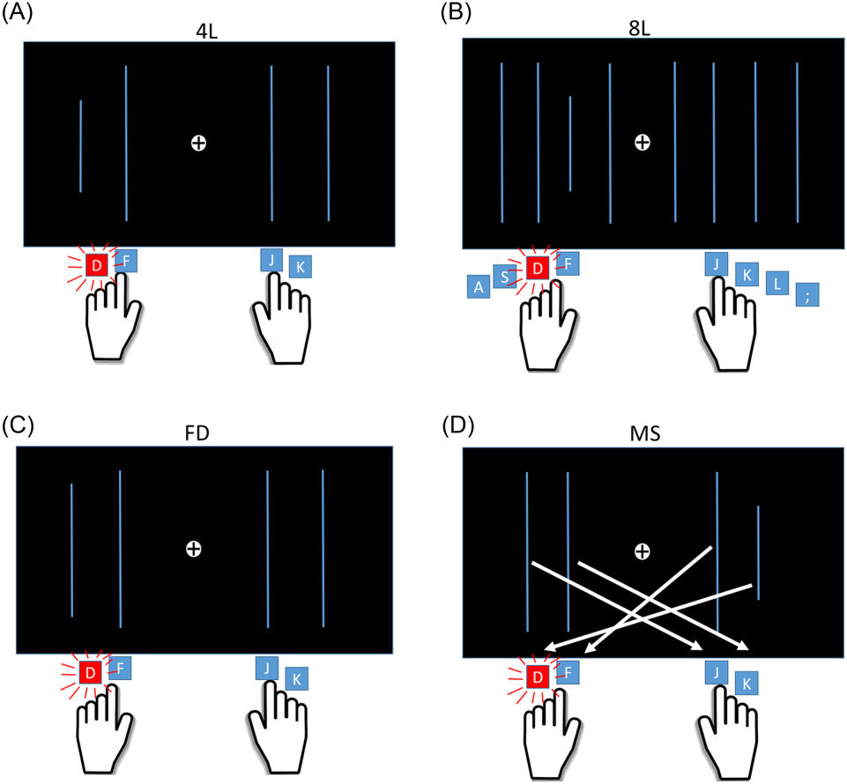

All rights, including for text and data mining, AI training, and similar technologies, are reserved.

Note. This ﬁgure illustrates the response rules for the four task conditions. In each condition, participants identiﬁed the position of the shortest line using either four response buttons (for the 4L,
FD, and MS conditions) or eight response buttons (for the 8L condition). Icons beneath each example indicate the correct response for that trial. The task conditions were as follows: (A) 4-line (4L)
condition: participants selected the shortest line from four options. (B) 8-line (8L) condition: parti- cipants selected the shortest line from eight options. (C) Fine discrimination (FD) condition: parti- cipants identiﬁed the shortest line from four options with minimal size differences. (D) Mapping switch
(MS) condition: participants selected the shortest line from four options with reversed stimulus– response mapping. Arrows indicate the correct key press for each position of the shortest line. See the online article for the color version of this ﬁgure.

The experiment consisted of three scanning sessions, each sep- arated by a 30-s break. Each session included 25 task blocks, ﬁve for each of the ﬁve conditions. The order of blocks within each session was pseudorandomly arranged.
The ﬁnal reaction time (RT) and accuracy will be used to calculate the inverse efﬁciency score (IES; Bruyer & Brysbaert, 2011; Townsend
& Ashby, 1978, 1983), which serves as a corrected behavioral measure that integrates both speed and accuracy (see Equation 1).
(4L, 8L, FD, MS) and for both age groups (younger and older
adults). Subsequently, we performed mixed-design repeated-mea- sures analyses of variances with a 2 (age group: younger vs. older) × 4 (condition: 4L, 8L, FD, MS) design on each task performance
measure. Post hoc comparisons were then conducted using the Holm correction to further explore and compare signiﬁcant differences between conditions. Importantly, in the main text, we reported only the IES results, as this metric integrates both RT and accuracy, accounting for potential performance trade-offs between the two
(1) groups.

IES = :

Design and Statistical Analysis

Behavioral Data: Task Performance Analysis Between the Two Age Groups

Behavioral performance measures—including RT, accuracy, and IES—were analyzed separately for each of the four conditions

Neuroimaging Data: fMRI Imaging Acquisition and Analysis

Imaging data for the visual discrimination task were collected using a 3 Tesla General Electric (GE) Discovery MR750 scanner (General Electric Medical Systems, Milwaukee, USA) at the Mind Research Imaging Center of National Cheng Kung University. The

852
All rights, including for text and data mining, AI training, and similar technologies, are reserved.

HSIEH, YANG, AND YAO

scanner was ﬁtted with a 32-channel receive-only phased-array head
coil. High-resolution structural scans were acquired with a fast spoiled gradient-recalled echo sequence. The imaging parameters were repetition time = 7.6 ms, echo time = 3.3 ms, ﬂip angle = 12°; ﬁeld of view = 22.4 × 22.4 cm2; matrix size = 224 × 224; slice thickness = 1. Functional echo planar imaging images were cap- tured using an interleaved T2* weighted gradient-echo planar imaging pulse sequence (repetition time/echo time/ﬂip angle: 2000 ms/30 ms/78°; matrix size: 64 × 64; ﬁeld of view: 22 × 22 cm2; slice
thickness: 3 mm; voxel size: 3.4375 × 3.4375 × 3 mm). Each session included 368 volumes, with the ﬁrst eight volumes discarded as dummy scans to account for T1 equilibrium effects.

fMRI Imaging Preprocessing

The preprocessing of functional imaging data was carried out using the FMRIB Software Library (FSL; FMRIB stands for the Functional Magnetic Resonance Imaging of the Brain Software Library; Jenkinson et al., 2012). The process began with motion artifact correction through the Motion Correction FMRIB’s Linear Image Registration Tool (MCFLIRT; Beckmann et al., 2003; Jenkinson & Smith, 2001; Jenkinson et al., 2002). Following this, nonbrain tissue was removed from the MR images using the Brain Extraction Tool
(Jenkinson et al., 2002). To identify outlier volumes, the FSL Motion Outliers tool (Jenkinson & Smith, 2001; Jenkinson et al., 2002) was applied, with outliers deﬁned as those exceeding the 75th percentile plus 1.5 times the interquartile range of frame displacement between volumes. These outliers were excluded from further analysis to minimize their impact. Each participant’s brain functional images were registered to their high-resolution T1 structural images via linear transformation, followed by the registration of the individual struc- tural images to the MNI152 template. A ﬁrst-level general linear model (GLM) analysis was performed using FSL’s FMRI Expert Analysis Tool (Woolrich et al., 2001, 2004), incorporating spatial smoothing with a 9 mm full-width half-maximum Gaussian kernel.

Statistical Analysis: Block Design fMRI Analysis

For every participant, a GLM was employed to estimate differ- ences across experimental conditions in the visual discrimination
task. Contrasts were conducted to identify regions that showed greater activation in the 8L, FD, and MS conditions compared with the 4L condition. The onset of each condition block was deﬁned from the start of the stimulus to the end of the block, and this was used to create the onset ﬁles. These ﬁles for each of the four conditions were included as explanatory variables in the GLM and were convolved with a double γ hemodynamic response function. The six head motion parameters, along with the motion outlier data from earlier steps, were incorporated as covariates to control for potential confounds.

Statistical Analysis of Condition-Related Effects

The data from the three runs will be averaged and entered into a group-level analysis to identify signiﬁcant clusters for the three contrasts (8L–4L, FD–4L, MS–4L) in both the younger and older adult groups. Signiﬁcant clusters of activity were identiﬁed using a cluster-level threshold of 0.05 and a z threshold of 3.1 for deﬁning contiguous clusters (Eklund et al., 2016). The signiﬁcance of each

cluster, based on Gaussian random ﬁeld theory, was compared with the probability threshold (Bansal et al., 2007). Sex and years of education were included as covariates in the design matrix by spec- ifying them in the explanatory variables (EVs) section of the model setup. Each covariate was mean-centered and added as an additional column in the design matrix. This allowed their effects to be modeled and regressed out from the group-level statistical analysis, thereby controlling for their potential confounding inﬂuence on the results.

Statistical Analyses Examining Age-Related
Effects and the Association Between Brain Activation and Behavioral Performance

To examine age-related differences in brain activity, three con- dition contrasts of interest were computed: 8L–4L, FD–4L, and MS– 4L were conducted separately for each participant. The resulting contrast images (COPEs) from the younger and older adult groups were then entered into a group-level analysis using FSL FMRI Expert Analysis Tool. A two-group unpaired t test was performed to compare the two age groups. Contrasts were deﬁned to identify brain regions showing greater activation in older compared with younger adults (O > Y), as well as regions showing greater activation in younger compared with older adults (Y > O). For each signiﬁcant cluster identiﬁed in both contrasts, spherical regions of interest (ROIs) with a 3 mm radius were created around the peak voxel coordinates provided by FSL. Within each ROI, the mean z values were extracted for each participant. These values were then used to investigate the relationship between brain activation and behavioral performance. Speciﬁcally, scatterplots were generated to examine the association between mean z values and IES scores. In each plot, data from the younger and older adult groups were displayed separately within the same ﬁgure, allowing for a visual comparison of brain–behavior relationships across age groups.

Results
Participants

A total of 80 participants were contacted and recruited. Among
these, two participants could not complete the experiment due to equipment failure, and another two were excluded from the magnetic resonance imaging experiment as they were unable to understand and complete the training and practice phases of the behavioral experiment. Additionally, four participants were excluded from the analysis due to an average accuracy of less than 0.5 in the behavioral experiment, raising concerns about random responses.
Ultimately, 36 younger participants (19 males, 17 females) and 36 older participants (16 males, 20 females) were included in the ﬁnal analysis. The younger participants had a mean age of 23.8 years (range = 19–33 years, SD = 3.34) and a mean of 16.11 years of education (range = 13–20 years, SD = 1.49). The older participants had a mean age of 67.1 years (range = 56–82 years, SD = 5.37) and a mean of 14.58 years of education (range = 9–20 years, SD = 2.48). All older adults scored in the normal range on the MoCA, a screening tool for mild cognitive impairment. The mean MoCA score for the older group was 28.61 (SD = 1.46, out of 30; see Table 1). This conﬁrms that our older participants were cognitively healthy older adults without evidence of signiﬁcant impairment. Refer to Table 1 for demographic details of the participants.

PREFRONTAL OVERACTIVATION IN OLDER ADULTS 853

Measure | Younger | Older | Paired t value
Age (years) | 23.84 ± 3.34 | 67.10 ± 5.37 | 41.07***
Education (years) MoCA | 16.11 ± 1.49 | 14.58 ± 2.48  28.61 ± 1.46 | −3.17**

Table 1
Demographic Information of the Participants

Note. MoCA = Montreal Cognitive Assessment.
** p < .01. *** p < .001.

Behavioral Data for the Visual Discrimination Task for Two Age Groups

Figure 2 presents the IES scores for the four conditions across the two age groups. A 2 × 4 mixed-design repeated-measures analyses of variance revealed a signiﬁcant main effect of condition, F(3, 210) = 45.68, p < .001, η = 0.40. Post hoc tests, adjusted using the Holm

correction for multiple comparisons, identiﬁed speciﬁc differences among the conditions. The 4L condition signiﬁcantly differed from the MS condition, t(71) = −10.66, p < .001, Cohen’s d = −1.68, the 8L condition also signiﬁcantly differed from the MS condition, t(71)
= −8.72, p < .001, Cohen’s d = −1.37, and the FD condition also signiﬁcantly differed from the MS condition, t(71) = −8.78, p < .001, Cohen’s d = −1.38.
Additionally, a signiﬁcant main effect of age group was observed, F(1, 70) = 49.09, p < .001, η = 0.41. The interaction effect between age group and conditions was also signiﬁcant, F(3, 210) = 21.62, p <
.001, η = 0.24, indicating that the relationship between group and condition varied signiﬁcantly across the four conditions. Further analysis showed that age group differences were signiﬁcant across all four conditions: 4L condition, F(1, 70) = 86.39, p < .001, Cohen’s d =
2.19; 8L condition, F(1, 70) = 63.29, p < .001, Cohen’s d = 1.88; FD condition, F(1, 70) = 34.18, p < .001, Cohen’s d = 1.38; and MS condition, F(1, 70) = 29.56, p < .001, Cohen’s d = 1.28.

Figure 2
Box Plots for Inverse Efﬁciency Score (IES) Across the Four Conditions (4L, 8L, FD, and MS) in Older and Younger Participants
All rights, including for text and data mining, AI training, and similar technologies, are reserved.

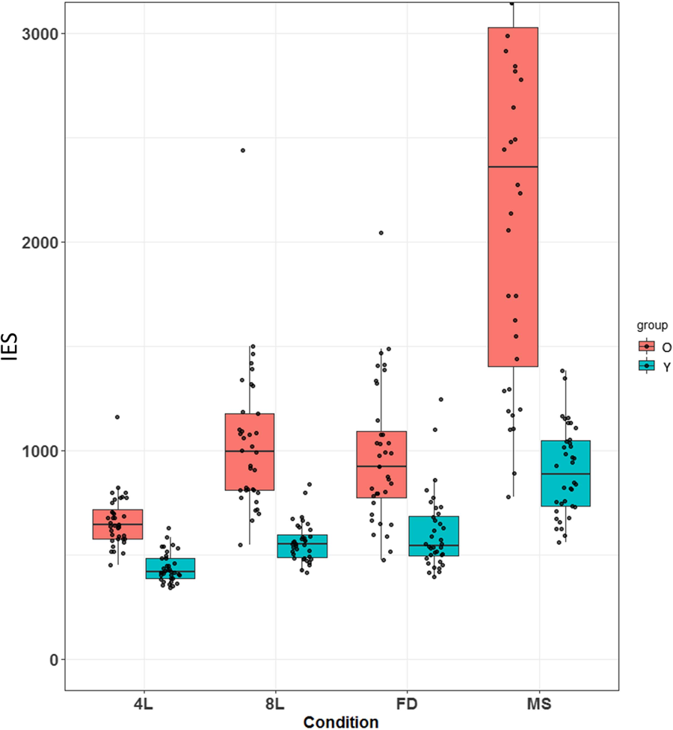

Note. 4L = 4-line; 8L = 8-line; FD = ﬁne discrimination; MS = mapping switch. Red boxes represent the older group (O), and cyan boxes represent the younger group’s (Y) inverse efﬁciency scores. Each box represents the interquartile range (IQR), spanning from the ﬁrst quartile (Q1, 25th percentile) to the third quartile (Q3, 75th percentile). The thick line within the box indicates the median. Whiskers extend to the smallest and largest values within 1.5 × IQR from Q1 and Q3. See the online article for the color version of this ﬁgure.

854

HSIEH, YANG, AND YAO

fMRI Results for the Visual Discrimination Task Whole-Brain Univariate Analysis of Paired-Contrast
Results for the Younger Group

To identify brain regions responsive to varying levels of difﬁ-
culty, we performed three paired contrasts: 8L–4L, FD–4L, and MS–4L, comparing these conditions across all younger participants. The contrast images, shown in Figure 3, were evaluated with a threshold of p < .01 and a 3.1 z threshold to deﬁne contiguous clusters (Eklund et al., 2016). Detailed cluster information can be found in Supplemental Table S1 which includes comprehensive statistical parameters, such as Z values, voxel coordinates, and cluster sizes for all contrasts (8L–4L, FD–4L, MS–4L).
Each of the contrasts (see Supplemental Table S1) revealed widespread activation throughout the frontoparietal cortex. Parietal activations for the 8L condition were more extensive and somewhat more anterior than those seen in the FD and MS conditions across both hemispheres. Activation was observed bilaterally in areas surrounding the intraparietal sulcus, including the inferior parietal and angular gyrus regions. On the medial surface of the PFC, near the middle cingulum, all three contrasts displayed signiﬁcant

activity, with the most extensive activation for MS and the most localized for 8L. Additionally, the peak activation in the medial PFC for the 8L condition was located more caudally compared with FD and MS.
Joint activation across all three contrasts was observed bilaterally in the anterior insula/frontal operculum, with the most restricted activation for the 8L–4L contrast. Notably, distinct activation patterns were found in the lateral frontal lobe. For the 8L–4L contrast, sig- niﬁcant activation in the left frontal lobe was concentrated around the precentral gyrus, with another notable cluster in the middle frontal region (−31, 36, 27). For the FD–4L contrast, activation appeared near the frontal operculum and insula (32, 24, −8). The MS–4L contrast showed widespread activation from the frontal pole, ex- tending along the ventral margin of the frontal lobe to the inferior and middle frontal regions.
In the right frontal lobe, the clusters under the 8L–4L contrast were primarily located around the precentral gyrus, with a larger activation cluster near the middle frontal region (36, 38, 19) compared with the left side. Interestingly, the pattern for the MS–4L contrast in the right frontal lobe mirrored that seen on the left side.
Moreover, the signiﬁcant clusters in the right frontal lobe for the

Figure 3
Average BOLD Signal Activation Changes Across Contrasts Between Conditions of Interest for All Younger Participants
All rights, including for text and data mining, AI training, and similar technologies, are reserved.

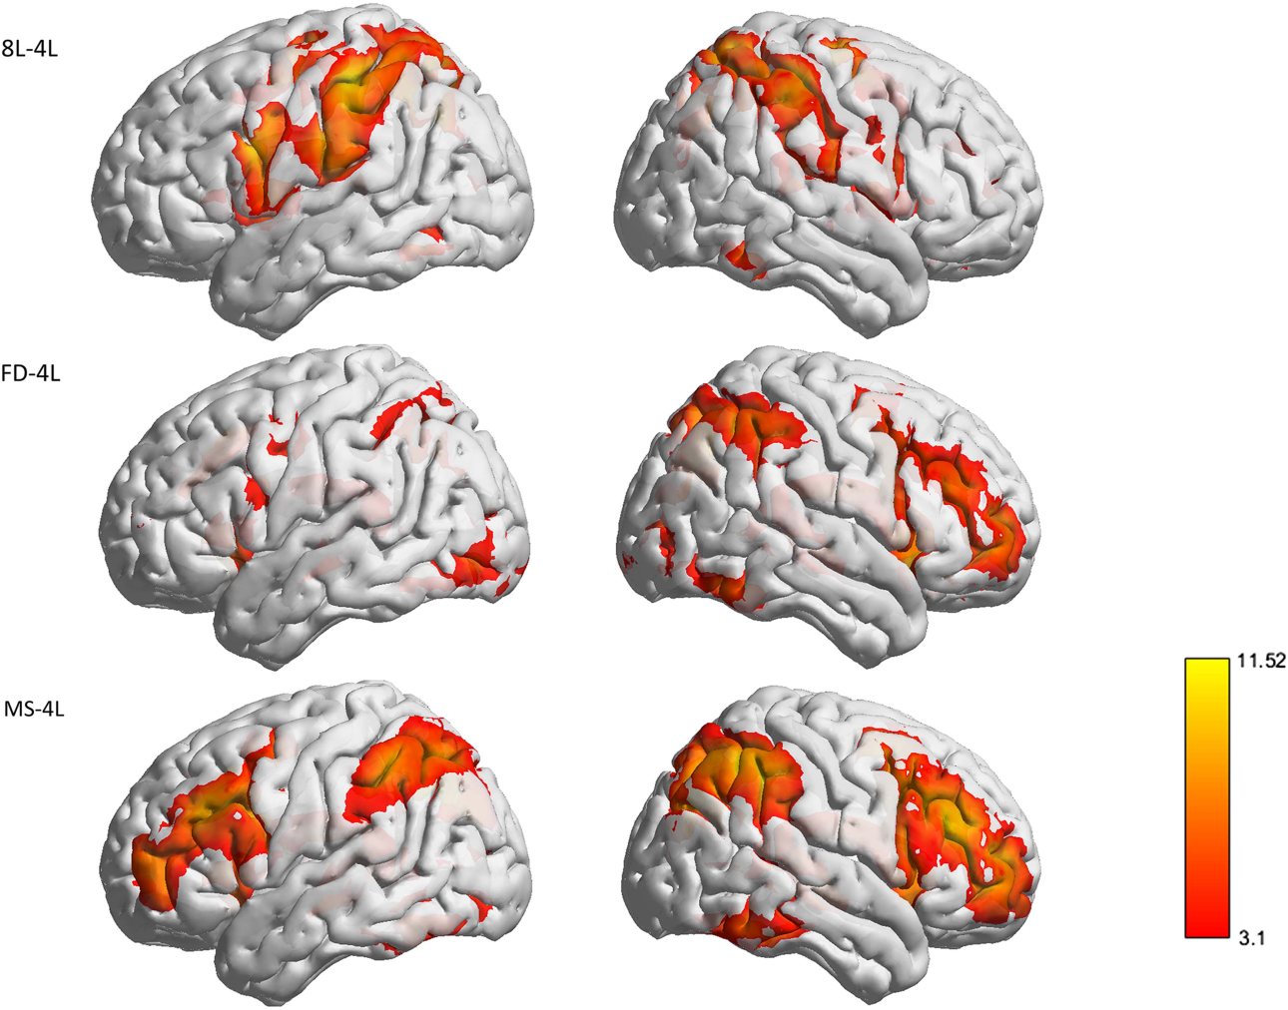

Note. 4L = 4-line; 8L = 8-line; FD = ﬁne discrimination; MS = mapping switch. The color bar shows thresholded Z statistic values (Z > 3.1). Warmer colors indicate stronger activation. The color scale ranges from 3.1 to 11.52. BOLD = blood-oxygen-level-dependent. See the online article for the color version of this ﬁgure.

PREFRONTAL OVERACTIVATION IN OLDER ADULTS 855

FD–4L contrast were nearly identical to those seen in the MS–4L
contrast.

Whole-Brain Univariate Analysis of Paired-Contrast Results for the Older Group

Similar to the younger group, we present the three contrasts of the older group in Figure 4. Detailed cluster information can be found in Supplemental Table S2 which includes comprehensive statistical
parameters, such as Z values, voxel coordinates, and cluster sizes for all contrasts (8L–4L, FD–4L, MS–4L). Notably, compared with the younger group, the older group shows larger clusters in the inferior temporal and temporal pole regions for the 8L–4L contrast.
Additionally, the cluster in the occipital region expands, and the frontal region extends anteriorly to include the inferior frontal and frontal pole areas.
In the FD–4L contrast, the older group shows an expansion of the cluster in the occipital region toward the posterior direction, while the frontal region expands toward the middle frontal area.
Additionally, it is noteworthy that the older group has more clusters exceeding the threshold on the left side compared with the

younger group (see Figure 4), resulting in more symmetrical acti- vation areas between the left and right hemispheres.
In the MS–4L contrast, the differences between the younger group and the older group are relatively small. However, the activation cluster in the frontal region is less localized in the older
group, forming a more continuous area.

Whole-Brain Univariate Analysis of Paired-Contrast Results Between Younger and Older Groups
(Older > Younger and Younger > Older Contrasts)

Whole-brain two-sample contrasts revealed age effects in both directions (i.e., older > younger and younger > older; see Figure 5A and 5B and Supplemental Table S3). Older adults showed greater activation than younger adults in prefrontal and anterior midline regions (older > younger; see Figure 5A and Supplemental Table S3), whereas younger adults exhibited higher activation in bilateral superior parietal cortex and occipital visual areas (younger > older; see Figure 5B and Supplemental Table S3). This pattern—reduced engagement of posterior attention and visual regions by older adults alongside increased frontal activation—is consistent with an age-

Figure 4
Average BOLD Signal Activation Changes Across Contrasts Between Conditions of Interest for All Older Participants
All rights, including for text and data mining, AI training, and similar technologies, are reserved.

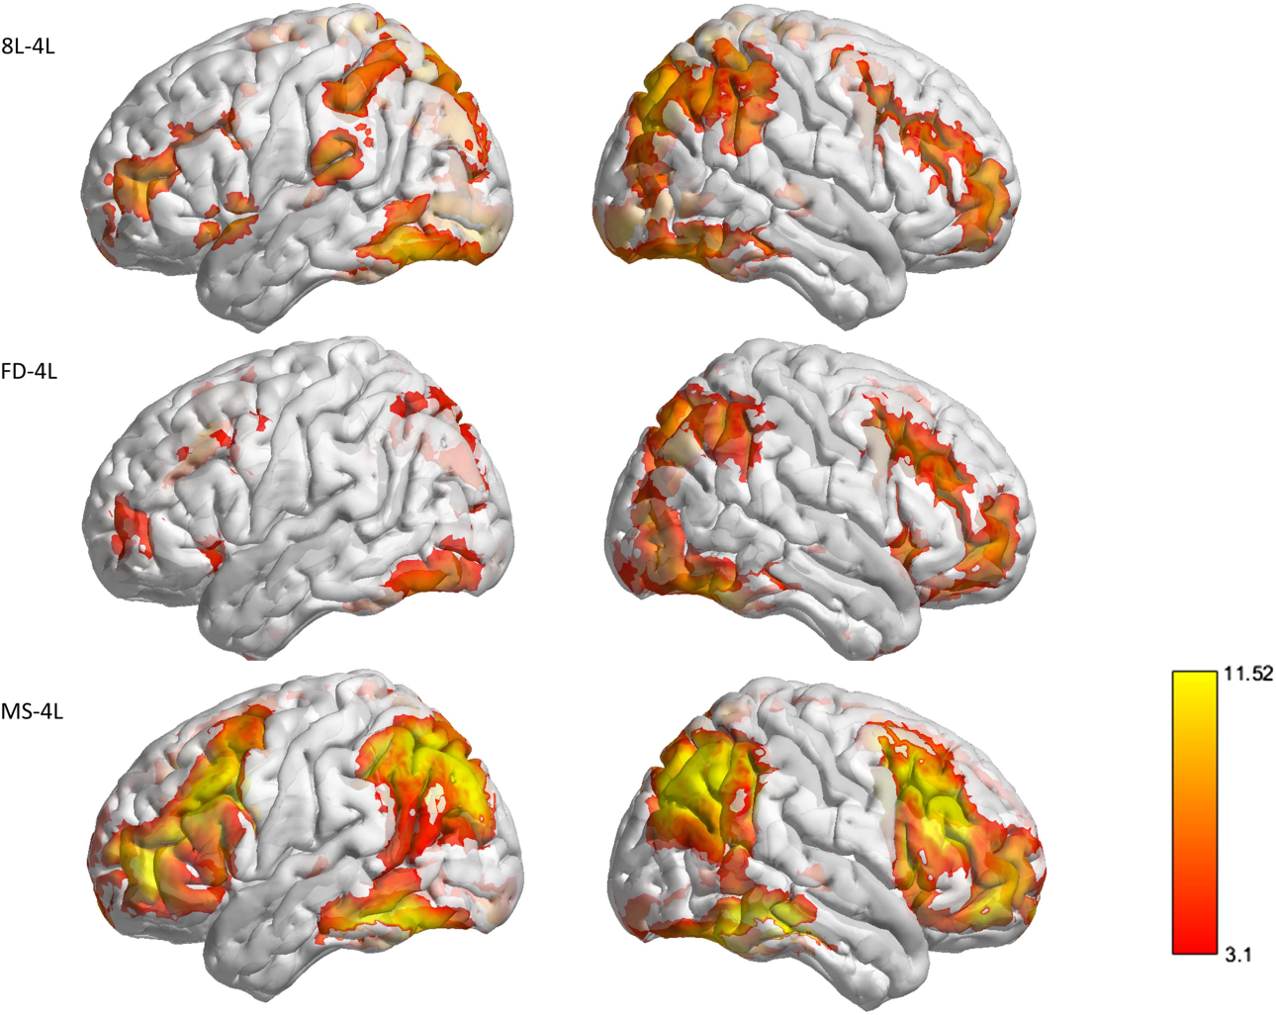

Note. 4L = 4-line; 8L = 8-line; FD = ﬁne discrimination; MS = mapping switch. The color bar shows thresholded Z statistic values (Z > 3.1). Warmer colors indicate stronger activation. The color scale ranges from 3.1 to 11.52. BOLD = blood-oxygen-level-dependent. See the online article for the color version of this ﬁgure.

856

HSIEH, YANG, AND YAO

Figure 5
Contrast Brain Activation Maps Between Younger and Older Groups for the Three Task Conditions in Both Directions (Older > Younger and Younger > Older), Along With Scatterplots Showing Correlations With Behavioral Performance

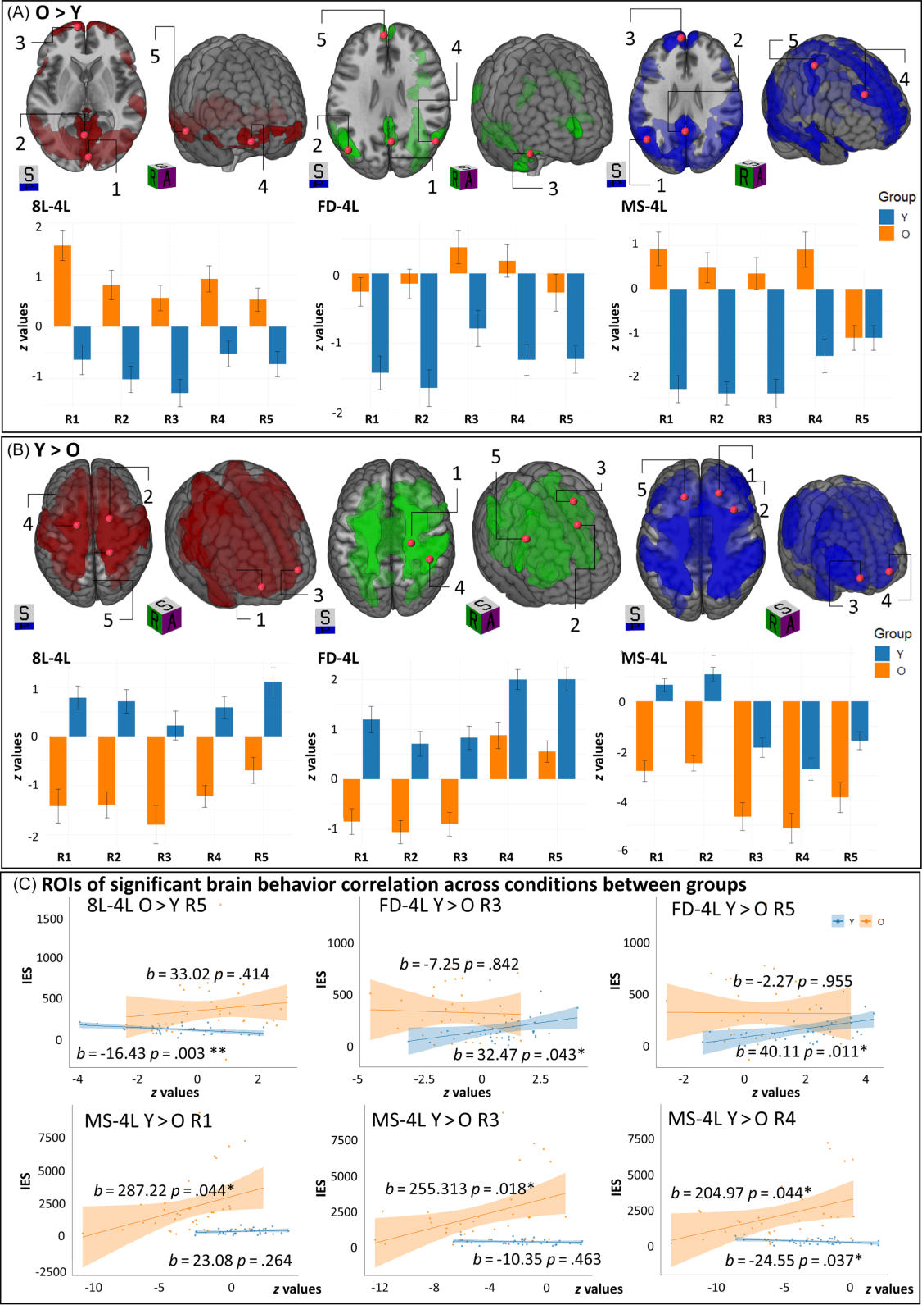
All rights, including for text and data mining, AI training, and similar technologies, are reserved.

Note. 4L = 4-line; 8L = 8-line; FD = ﬁne discrimination; MS = mapping switch. From left to right, the signiﬁcant brain activation regions across three contrasts 8L–4L (red in spatial map), FD–4L (green in spatial map), and MS–4L (blue in spatial map) are shown. A = older > younger (O > Y); B = younger > older (Y > O); C = signiﬁcant clusters (Z scores of β values) showing correlations between group contrast and behavior (IES), with scatterplots and ﬁtted regression lines. R = ROI. See Supplemental Tables S4–S6 for ROI numbers (1–5; R1–R5), corresponding coordinates, and associated brain regions. ROI = regions of interest. See the online article for the color version of this ﬁgure.
* p < .05. ** p < .01.

PREFRONTAL OVERACTIVATION IN OLDER ADULTS 857
All rights, including for text and data mining, AI training, and similar technologies, are reserved.

related posterior-to-anterior shift (i.e., PASA) in neural recruitment.
Furthermore, preliminary observations suggested that older adults exhibited reduced task-induced deactivation in DMN regions, along with weaker recruitment of DAN areas, relative to younger adults. These neural differences, particularly under high task demand, and their associations with performance are described in detail in subsequent sections.
To further investigate the functional signiﬁcance of the age- related differences in activation, we extracted the mean z values from the signiﬁcant clusters identiﬁed in both the older > younger and younger > older contrasts for each condition (8L–4L, FD–4L, MS–4L; see Figure 5 and Supplemental Table S3). We then cor- related these extracted activation values with individual IESs within each age group (Supplemental Figures S1–S2 and Tables S4–S6).
For regions identiﬁed in the older > younger contrast, activation– performance relationships in older adults generally did not reach signiﬁcance, indicating a lack of reliable association with task
performance. In contrast, for regions where younger adults showed greater activation than older adults (younger > older contrast), a task-dependent relationship between activation and performance in older adults emerged. Speciﬁcally, under the highest task demand condition (MS–4L contrast), signiﬁcant positive correlations were observed in anterior regions, including the frontal pole and orbi- tofrontal cortex, indicating that higher activation in these areas was reliably linked to less efﬁcient performance (i.e., higher IES).
Overall, these ﬁndings suggest that age-related overactivation exhibits region-speciﬁc rather than uniform associations with
behavior. In older adults, certain lateral frontal clusters showed increased activation coupled with poorer performance under high task demands; however, this pattern did not extend to other regions. To transparently illustrate these differential brain–behavior re-
lationships, individual subject-level scatterplots are provided in the Supplemental Figures S1–S2 and Tables S4–S6, along with regression diagnostics and age-group contrasts.

Task-Related Deactivation Versus Activation

Older adults demonstrated a reduction in task-induced deactivation within the DMN. During task performance, older adults exhibited higher activation in DMN regions (e.g., medial frontal cortex, pos- terior cingulate) compared with younger adults, who showed the typical below-baseline deactivation in these areas. Conversely, younger adults more strongly engaged the DAN than older adults. For instance, task-related activation in the intraparietal sulcus and frontal eye ﬁelds was greater in younger adults, indicating age-related un- derrecruitment of attentional networks in older adults. These patterns are illustrated in Supplemental Figures S3–S4.
Crucially, older adults also exhibited signiﬁcant differences in task-induced DMN deactivation relative to younger adults. Speciﬁcally, older adults showed signiﬁcantly less deactivation—or even positive activation—in canonical DMN regions, including the medial PFC and posterior cingulate cortex (p < .001; see Figure 5A and Supplemental Table S3). Younger adults, in contrast, displayed robust DMN deactivation during task engagement, which was associated with more efﬁcient performance. Together, these ﬁndings suggest that older adults experience difﬁculty suppressing the DMN and concurrently exhibit weaker activation of task-relevant atten- tional networks, potentially contributing to their performance deﬁcits.

In contrast to the DMN, regions within the DAN—which closely overlapped with the younger > older activation clusters identiﬁed in our analysis (see Figure 5B and Supplemental Figure S4)—exhibited a distinct behavioral association in the older group. Speciﬁcally, under the highest task demand condition (MS–4L contrast), we observed a signiﬁcant negative correlation between DAN activation and performance among older adults (see Figure 5C). That is, higher activation in canonical DAN regions such as the intraparietal sulcus and frontal eye ﬁelds was associated with poorer behavioral out- comes in the older cohort. It is possible that, when challenged by the MS–4L condition, older adults attempt to recruit the DAN but do so in a less targeted or more diffuse manner, resulting in over- engagement that fails to translate into performance beneﬁts.

Discussion

The present study systematically examined prefrontal over- activation across varying cognitive demands using a visual dis- crimination task, providing clear support for the CRUNCH model
(Reuter-Lorenz & Cappell, 2008; Schneider-Garces et al., 2010). Older adults consistently showed greater brain activation than younger adults across all cognitive load conditions, with the largest difference observed under the highest demand (MS–4L). Notably, the observed age-related brain overactivation exhibits region-speciﬁc rather than uniform associations with behavior. In older adults, brain regions where younger adults showed greater activation—primarily in more lateral portions of the frontal pole—exhibited a signiﬁcant negative correlation between activation and performance, indicating that higher activation in these areas was linked to poorer efﬁciency. This relationship, however, did not extend to other regions.
Conversely, younger adults showed greater activation in posterior attentional and visual processing regions (e.g., superior parietal
cortex, occipital areas), highlighting a posterior-to-anterior shift with aging, consistent with the PASA model (Davis et al., 2008). These ﬁndings emphasize a clear dissociation: older adults’ addi- tional frontal recruitment occurs alongside reduced posterior
engagement, particularly under conditions of maximal cognitive
demand. This pattern is consistent with Cabeza et al. (2018), who argue that aging-related overactivation can reﬂect both compen- satory engagement and dedifferentiation, depending on the task demands and whether the recruitment beneﬁts performance. Our ﬁndings reveal a regionally differentiated pattern within the PFC. Across most prefrontal regions, increased activation in older adults did not reliably predict performance outcomes. However, signiﬁcant negative correlations emerged in the lateral frontal pole—regions where younger adults typically showed greater engagement— indicating that higher activation was associated with poorer efﬁ- ciency in older adults. This supports the notion that overactivation may reﬂect unsuccessful compensation in speciﬁc subregions, re- inforcing the idea that prefrontal engagement in aging is functionally
heterogeneous.
Behavioral performance results provided a clear and interpretable foundation for our neuroimaging ﬁndings. As expected, both younger and older adults showed increasing task difﬁculty reﬂected in worsening IES across the task continuum. However, older adults demonstrated slower reaction times and reduced accuracy across all
conditions, resulting in signiﬁcantly higher IES. These differences were especially pronounced in the MS–4L condition, which com- bined complex stimulus discrimination with unpredictable response

858
All rights, including for text and data mining, AI training, and similar technologies, are reserved.

HSIEH, YANG, AND YAO

mappings. The disproportionate increase in IES for older adults in this condition reﬂects a nonlinear decline in cognitive efﬁciency with increasing task complexity, consistent with prior research on age-related deﬁcits in executive control, task switching, and interference resolution (Braver & West, 2008; Verhaeghen &
Cerella, 2002). Importantly, this behavioral pattern aligns with the
CRUNCH, which predicts that older adults experience increasing difﬁculty as task demands approach or exceed their compensatory
limits. The steep performance decline under MS–4L thus provides behavioral evidence of cognitive overload, supporting our neural ﬁndings that frontal overactivation at this level is no longer effective but maladaptive. The relative parity in performance between age groups under low and moderate task demands suggests that com- pensatory mechanisms may initially preserve behavioral efﬁciency in older adults, but ultimately fail when demand exceeds neural
capacity. This echoes the load-dependent collapse proposed by both CRUNCH and STAC-r (Mattay et al., 2006; Park & Reuter-Lorenz, 2009; Schneider-Garces et al., 2010). Cabeza et al. (2018) suggested that compensatory responses in aging are most effective when there is still sufﬁcient neural reserve and connectivity to support task- relevant processing. Our behavioral ﬁndings, especially under MS–
4L, are consistent with this notion: older adults’ compensatory responses may become ineffective or even detrimental when the cognitive system is pushed beyond its adaptable limits.
Critically, our neuroimaging results (Figure 5) reinforce this
interpretation. Frontal overactivation under the MS–4L condition was functionally heterogeneous—particularly in lateral regions where younger adults showed greater activation than older adults (Y > O)—and these regions exhibited signiﬁcant negative corre- lations with performance, suggesting unsuccessful or inefﬁcient compensation (Dennis & Cabeza, 2011). By employing parametric task manipulations, our study extended previous binary-load CRUNCH paradigms, illustrating a gradual erosion of compen- satory efﬁcacy (Morcom & Henson, 2018). Cabeza et al. (2018) emphasized evaluating the relationship between activation and performance to distinguish compensation from maladaptive recruit- ment. Our use of IES helps clarify this distinction—overactivation in the absence of behavioral beneﬁt should not be interpreted as compensatory.
Frontal regions exhibited a clear quantitative difference: speciﬁ- cally, lateral frontal clusters—where younger adults typically out- perform older adults—showed signiﬁcant negative correlations with IES in older adults, suggesting maladaptive overactivation under high demand (MS–4L). While theories such as STAC-r (Reuter-Lorenz & Park, 2014) and hierarchical models (Badre & Nee, 2018) propose that certain anterior PFC subregions may offer transient compen- satory support, our data do not reveal a clear adaptive role for these regions under high cognitive load. The absence of signiﬁcant positive activation–performance correlations suggests that, when demands exceed capacity, these areas may fail to support performance. These frameworks emphasize that compensation is region-speciﬁc, de- pending on structural integrity, connectivity, and functional spe- cialization (Cabeza et al., 2018; Morcom & Henson, 2018). Our ﬁndings align with this view: while some lateral frontal regions show maladaptive recruitment, other anterior areas exhibit no signiﬁcant relationship with performance—highlighting functional heteroge- neity within the PFC. Overall, our results support the view that frontal engagement in aging reﬂects region-speciﬁc limitations rather than a uniform compensatory process. Cabeza et al. (2018) similarly argued

that compensation varies with task demands and regional speciali- zation. Our results provide empirical support for this position, showing task- and region-speciﬁc distinctions in the utility of frontal overactivation. These results align with evidence that age-related structural atrophy and functional inefﬁciency are not uniformly distributed across the cortex (Fjell et al., 2009), and suggest that the success or failure of compensatory engagement may depend on both regional capacity and task context (Spreng & Turner, 2019). Our ﬁndings therefore underscore the value of parametric task designs for tracing dynamic changes in the effectiveness of compensatory activation in aging.
Older adults also exhibited altered activation patterns in large-scale networks. Speciﬁcally, reduced DMN suppression under high load suggests impaired inhibition of task-irrelevant processes (C. L. Grady et al., 2010; Spreng et al., 2016). While this may reﬂect general deactivation deﬁcits, it could also indicate inefﬁcient switching between internal and external modes, a hallmark of cognitive aging. Similarly, altered DAN engagement may reﬂect changes in top-down attentional control. However, given our reliance on spatial overlap rather than connectivity, these interpretations remain tentative. Future work using connectivity and graph-theoretical approaches is needed to clarify these network-level changes.
While our ﬁndings emphasize task demand in shaping neural recruitment in aging, the observed effects may be domain-speciﬁc. Our task engaged frontoparietal networks involved in executive function and perceptual decisions (Crittenden & Duncan, 2014). Other domains (e.g., episodic memory) engage distinct circuits with potentially different compensation proﬁles (Yassa et al., 2011). STAC suggests that compensation occurs across domains, but with varying neural substrates and efﬁcacy. Cross-domain studies using comparable paradigms are needed to determine whether CRUNCH and STAC-r principles are generalizable. Our domain-speciﬁc re- sults nevertheless support the broader claim of Cabeza et al. (2018): compensation and dedifferentiation can co-occur, varying in adaptiveness depending on the circuits and demands involved.
Several limitations warrant consideration. First, reliance on IES may obscure speciﬁc mechanisms due to sensitivity to error rates and speed–accuracy trade-offs (Bruyer & Brysbaert, 2011). Although error rates were modest (<10% in most conditions), they exceeded 15% in MS–4L for older adults. Still, supplementary analyses conﬁrmed that the age-related patterns were robust. Second, lack of a ﬁxation baseline limits our inferences about DMN suppression. Future work should include rest conditions to isolate task-negative activity. Third, unmeasured factors like cognitive reserve and lifestyle may inﬂuence compensation (Cabeza et al., 2018; Stern, 2002). Finally, longitudinal studies are needed to determine whether these brain–behavior shifts predict cognitive decline or resilience.

Conclusion

This study provided strong evidence for a graded, capacity- limited model of neural compensation in aging, consistent with the CRUNCH and STAC-r frameworks. Frontal overactivation was initially associated with adaptive responses but became maladaptive under high demand (MS–4L), suggesting limits to compensatory
mechanisms. These ﬁndings extend prior research by demonstrating gradual declines in compensation shaped by task complexity and regional specialization.

PREFRONTAL OVERACTIVATION IN OLDER ADULTS 859
All rights, including for text and data mining, AI training, and similar technologies, are reserved.

Our results support Cabeza et al.’s (2018) integrative framework, showing that compensation, dedifferentiation, and inefﬁciency coexist and vary with context and activation–performance dynamics. They also align with the PASA and STAC-r models, highlighting a dynamic interplay between posterior underrecruitment and anterior overrecruitment as a function of task demands and regional neural capacity.
Practically, the ﬁndings suggest that tracking the trajectory of IESs across escalating task demands (from 4L to 8L to FD to MS) could offer a sensitive behavioral indicator of cognitive vulnerability in older adults. A steeper IES slope—reﬂecting a sharper efﬁciency drop under increasing cognitive load—may help identify individuals at greater risk for age-related decline. These insights underscore the value of adjusting task complexity to better align with individuals’ cognitive capacity at different ages, not only in cognitive assessments but also in the design of training environments, workplace demands, and everyday public settings. Tailored cognitive training paradigms that scaffold task demands and foster more efﬁcient recruitment of cognitive resources could support cognitive health and enhance age- friendliness in diverse applied contexts.

References

Andersen, G. J. (2012). Aging and vision: Changes in function and per- formance from optics to perception. Wiley Interdisciplinary Reviews: Cognitive Science, 3(3), 403–410. https://doi.org/10.1002/wcs.1167
Badre, D., & Nee, D. E. (2018). Frontal cortex and the hierarchical control of
behavior. Trends in Cognitive Sciences, 22(2), 170–188. https://doi.org/10
.1016/j.tics.2017.11.005
Bansal, R., Staib, L. H., Xu, D., Zhu, H., & Peterson, B. S. (2007). Statistical analyses of brain surfaces using Gaussian random ﬁelds on 2-D manifolds. IEEE Transactions on Medical Imaging, 26(1), 46–57. https://doi.org/10
.1109/TMI.2006.884187
Beckmann, C. F., Jenkinson, M., & Smith, S. M. (2003). General multilevel linear modeling for group analysis in FMRI. NeuroImage, 20(2), 1052–
1063. https://doi.org/10.1016/S1053-8119(03)00435-X
Braver, T. S., & West, R. L. (2008). Working memory, executive control, and
aging. In F. I. M. Craik & T. A. Salthouse (Eds.), The handbook of aging and cognition (3rd ed., pp. 311–372). Psychology Press.
Bruyer, R., & Brysbaert, M. (2011). Combining speed and accuracy in cognitive psychology: Is the inverse efﬁciency score (IES) a better dependent variable than the mean reaction time (RT) and the percentage of errors (PE)? Psychologica Belgica, 51(1), Article 5. https://doi.org/10
.5334/pb-51-1-5
Cabeza, R., Albert, M., Belleville, S., Craik, F. I. M., Duarte, A., Grady,
C. L., Lindenberger, U., Nyberg, L., Park, D. C., Reuter-Lorenz, P. A.,
Rugg, M. D., Steffener, J., & Rajah, M. N. (2018). Maintenance, reserve and compensation: The cognitive neuroscience of healthy ageing. Nature Reviews Neuroscience, 19(11), 701–710. https://doi.org/10.1038/s41583-018-0068-2
Crittenden, B. M., & Duncan, J. (2014). Task difﬁculty manipulation reveals multiple demand activity but no frontal lobe hierarchy. Cerebral Cortex, 24(2), 532–540. https://doi.org/10.1093/cercor/bhs333
Davis, S. W., Dennis, N. A., Daselaar, S. M., Fleck, M. S., & Cabeza, R.
(2008). Que PASA? The posterior-anterior shift in aging. Cerebral Cortex, 18(5), 1201–1209. https://doi.org/10.1093/cercor/bhm155
Dennis, N. A., & Cabeza, R. (2011). Neuroimaging of healthy cognitive
aging. In F. I. M. Craik & T. A. Salthouse (Eds.), The handbook of aging and cognition (3rd ed., pp. 1–54). Psychology Press. https://doi.org/10
.4324/9780203837665.ch1

Duncan, J. (2010). The multiple-demand (MD) system of the primate brain: Mental programs for intelligent behaviour. Trends in Cognitive Sciences, 14(4), 172–179. https://doi.org/10.1016/j.tics.2010.01.004
Duncan, J., & Owen, A. M. (2000). Common regions of the human frontal lobe recruited by diverse cognitive demands. Trends in Neurosciences, 23(10), 475–483. https://doi.org/10.1016/S0166-2236(00)01633-7
Eklund, A., Nichols, T. E., & Knutsson, H. (2016). Cluster failure: Why fMRI inferences for spatial extent have inﬂated false-positive rates. Proceedings of the National Academy of Sciences of the United States of America, 113(28), 7900–7905. https://doi.org/10.1073/pnas.1602 413113
Faul, F., Erdfelder, E., Lang, A. G., & Buchner, A. (2007). G*Power 3: A ﬂexible statistical power analysis program for the social, behavioral, and biomedical sciences. Behavior Research Methods, 39(2), 175–191. https:// doi.org/10.3758/BF03193146
Fjell, A. M., Walhovd, K. B., Fennema-Notestine, C., McEvoy, L. K., Hagler,
D. J., Holland, D., Brewer, J. B., & Dale, A. M. (2009). One-year brain atrophy evident in healthy aging. The Journal of Neuroscience, 29(48), 15223–15231. https://doi.org/10.1523/JNEUROSCI.3252-09.2009
Grady, C. (2012). The cognitive neuroscience of ageing. Nature Reviews Neuroscience, 13(7), 491–505. https://doi.org/10.1038/nrn3256
Grady, C. L., Protzner, A. B., Kovacevic, N., Strother, S. C., Afshin-Pour, B.,
Wojtowicz, M., Anderson, J. A., Churchill, N., & McIntosh, A. R. (2010). A multivariate analysis of age-related differences in default mode and task- positive networks across multiple cognitive domains. Cerebral Cortex, 20(6), 1432–1447. https://doi.org/10.1093/cercor/bhp207
Hsieh, S., Yang, M.-H., & Yao, Z.-F. (2025). Prefrontal overrecruitment in older adults: Task demand–dependent efﬁciency and implications for cognitive aging [Data set]. https://osf.io/7jtsy/
Jenkinson, M., Bannister, P., Brady, M., & Smith, S. (2002). Improved optimization for the robust and accurate linear registration and motion correction of brain images. NeuroImage, 17(2), 825–841. https://doi.org/
10.1006/nimg.2002.1132
Jenkinson, M., Beckmann, C. F., Behrens, T. E., Woolrich, M. W., & Smith,
S. M. (2012). FSL. NeuroImage, 62(2), 782–790. https://doi.org/10.1016/j
.neuroimage.2011.09.015
Jenkinson, M., & Smith, S. (2001). A global optimisation method for robust afﬁne registration of brain images. Medical Image Analysis, 5(2), 143–
156. https://doi.org/10.1016/S1361-8415(01)00036-6
Mathôt, S., Schreij, D., & Theeuwes, J. (2012). OpenSesame: An open-
source, graphical experiment builder for the social sciences. Behavior Research Methods, 44(2), 314–324. https://doi.org/10.3758/s13428-011-0168-7
Mattay, V. S., Fera, F., Tessitore, A., Hariri, A. R., Berman, K. F., Das, S., Meyer-Lindenberg, A., Goldberg, T. E., Callicott, J. H., & Weinberger,
D. R. (2006). Neurophysiological correlates of age-related changes in working memory capacity. Neuroscience Letters, 392(1–2), 32–37. https:// doi.org/10.1016/j.neulet.2005.09.025
Monge, Z. A., & Madden, D. J. (2016). Linking cognitive and visual per- ceptual decline in healthy aging: The information degradation hypothesis. Neuroscience and Biobehavioral Reviews, 69, 166–173. https://doi.org/10
.1016/j.neubiorev.2016.07.031
Morcom, A. M., & Henson, R. N. A. (2018). Increased prefrontal activity with aging reﬂects nonspeciﬁc neural responses rather than compensation. The Journal of Neuroscience, 38(33), 7303–7313. https://doi.org/10.1523/ JNEUROSCI.1701-17.2018
Nasreddine, Z. S., Phillips, N. A., Bédirian, V., Charbonneau, S., Whitehead,
V., Collin, I., Cummings, J. L., & Chertkow, H. (2005). The Montreal Cognitive Assessment, MoCA: A brief screening tool for mild cognitive
impairment. Journal of the American Geriatrics Society, 53(4), 695–699.
https://doi.org/10.1111/j.1532-5415.2005.53221.x
Owsley, C. (2011). Aging and vision. Vision Research, 51(13), 1610–1622.
https://doi.org/10.1016/j.visres.2010.10.020

860

HSIEH, YANG, AND YAO

Park, D. C., & Reuter-Lorenz, P. (2009). The adaptive brain: Aging and neurocognitive scaffolding. Annual Review of Psychology, 60(1), 173–196.
https://doi.org/10.1146/annurev.psych.59.103006.093656
Raz, N., Lindenberger, U., Rodrigue, K. M., Kennedy, K. M., Head, D., Williamson, A., Dahle, C., Gerstorf, D., & Acker, J. D. (2005). Regional brain changes in aging healthy adults: General trends, individual differ- ences and modiﬁers. Cerebral Cortex, 15(11), 1676–1689. https://doi.org/ 10.1093/cercor/bhi044
Raz, N., & Rodrigue, K. M. (2006). Differential aging of the brain: Patterns, cognitive correlates and modiﬁers. Neuroscience and Biobehavioral Reviews, 30(6), 730–748. https://doi.org/10.1016/j.neubiorev.2006.07.001
Reuter-Lorenz, P. A., & Cappell, K. A. (2008). Neurocognitive aging and the compensation hypothesis. Current Directions in Psychological Science, 17(3), 177–182. https://doi.org/10.1111/j.1467-8721.2008.00570.x
Reuter-Lorenz, P. A., & Park, D. C. (2014). How does it STAC up? Revisiting the scaffolding theory of aging and cognition. Neuropsychology Review, 24(3), 355–370. https://doi.org/10.1007/s11065-014-9270-9
Schneider-Garces, N. J., Gordon, B. A., Brumback-Peltz, C. R., Shin, E.,
Lee, Y., Sutton, B. P., Maclin, E. L., Gratton, G., & Fabiani, M. (2010).
Span, CRUNCH, and beyond: Working memory capacity and the aging
brain. Journal of Cognitive Neuroscience, 22(4), 655–669. https://doi.org/ 10.1162/jocn.2009.21230
Spreng, R. N., Stevens, W. D., Viviano, J. D., & Schacter, D. L. (2016). Attenuated anticorrelation between the default and dorsal attention networks with aging: Evidence from task and rest. Neurobiology of Aging, 45, 149–160. https://doi.org/10.1016/j.neurobiolaging.2016
.05.020
Spreng, R. N., & Turner, G. R. (2019). The shifting architecture of cognition and brain function in older adulthood. Perspectives on Psychological Science, 14(4), 523–542. https://doi.org/10.1177/1745691619827511

Stern, Y. (2002). What is cognitive reserve? Theory and research application of the reserve concept. Journal of the International Neuropsychological Society, 8(3), 448–460. https://doi.org/10.1017/S1355617702813248
Townsend, J. T., & Ashby, F. G. (1978). Methods of modeling capacity in simple processing systems. In J. T. Townsend (Ed.), Stochastic modeling of elementary psychological processes (pp. 261–307). Lawrence Erlbaum
Associates.
Townsend, J. T., & Ashby, F. G. (1983). Stochastic modeling of elementary psychological processes. CUP Archive.
Verhaeghen, P., & Cerella, J. (2002). Aging, executive control, and attention: A review of meta-analyses. Neuroscience and Biobehavioral Reviews, 26(7), 849–857. https://doi.org/10.1016/S0149-7634(02)00071-4
Woolrich, M. W., Behrens, T. E. J., Beckmann, C. F., Jenkinson, M., &
Smith, S. M. (2004). Multilevel linear modelling for FMRI group analysis using Bayesian inference. NeuroImage, 21(4), 1732–1747. https://doi.org/ 10.1016/j.neuroimage.2003.12.023
Woolrich, M. W., Ripley, B. D., Brady, M., & Smith, S. M. (2001). Temporal autocorrelation in univariate linear modeling of FMRI data. NeuroImage, 14(6), 1370–1386. https://doi.org/10.1006/nimg.2001.0931
Yassa, M. A., Mattfeld, A. T., Stark, S. M., & Stark, C. E. (2011). Age-related memory deﬁcits linked to circuit-speciﬁc disruptions in the hippocampus. Proceedings of the National Academy of Sciences of the United States of America, 108(21), 8873–8878. https://doi.org/10.1073/pnas.1101567108

Received January 27, 2025
Revision received June 5, 2025 Accepted June 6, 2025 ▪

All rights, including for text and data mining, AI training, and similar technologies, are reserved.

E-Mail Notification of Your Latest Issue Online!


Would you like to know when the next issue of your favorite APA journal will be available
online? This service is now available to you. Sign up at https://my.apa.org/portal/alerts/ and you will be notified by e-mail when issues of interest to you become available!

Reproduced with permission of copyright owner. Further reproduction prohibited without permission.

